H.T No
Regulations:
A22

Sreenidhi Institute of Science and Technology
(An Autonomous Institution)
Code No:9D301 Date: 04-September-2024 (FN)

B.Tech II-Year I- Semester External Examination, September -2024 (Supplementary)
DISCRETE STRUCTURES AND GRAPH THEORY (ECM)

Time: 3 Hours Max.Marks:60

Note: a) No additional answer sheets will be provided.
b) All sub-parts of a question must be answered at one place only, otherwise it will not be valued.
c) Missing data can be assumed suitably.
Bloom's Cognitive Levels of Learning (BCLL)

Remember | L1 | Apply | L3 | Evaluate | L5
Understand | L2 | Analyze | L4 | Create | L6

Part - A Max.Marks: 6x2=12

Answer all QUESTIONS, EACH QUESTION CARRIES 2 MARKS.

 |  | BCLL | CO(s) | Marks
1 | State the converse, inverse and contrapositive of P→Q | L2 | CO1 | [2M]
2 | Define Existential Generalization | L1 | CO2 | [2M]
3 | Write any two properties of binary relations | L2 | CO3 | [2M]
4 | Explain Bijection function with example | L3 | CO4 | [2M]
5 | Give an example of Homogeneous Recurrence Relation | L3 | CO5 | [2M]
6 | What is a Bipartite Graph | L2 | CO6 | [2M]

Part – B Max.Marks: 6x8=48
ANSWER ALL QUESTIONS. EACH QUESTION CARRIES 8 MARKS.

 |  | BCLL | CO(s) | Marks
7. | Show that (R ∨ S) follows logically from the premises  C ∨ D, (C ∨ D) →∼H, ∼H →(A ∧∼B), (A ∧∼B) → (R ∨ S ) | L5 | CO1 | [8M]
 | OR
8 | Construct truth table for [(p∧q) ∨(∼r)] ↔ p] | L4 | CO1 | [8M]
9. | Symbolize the following argument and check for its validity:  Every living thing is a plant or animal.  David’s dog is alive and it is not a plant.  All animals have Hearts.  Hence, David’s dog has a heart | L6 | CO2 | [8M]
 | OR
10 | Prove the following argument, using symbolic logic.  All men are fallible.  All kings are men.  Therefore, all kings are fallible. | L4 | CO2 | [8M]
11 | Show that G = {1, –1, i, –i } is an abelian group under multiplication. | L5 | CO3 | [8M]
 | OR
12 | Draw the Hasse diagram for the poset [ D₄₅ ; ⏐].Check if it is a complemented lattice.If yes, give the complements. | L6 | CO3 | [8M]
13 | If there are 200 faculty members that speak French, 50 that speak Russian, 100 that speak Spanish, 20 that speak French and Russian , 60 that speak French and Spanish, 35 that speak Russian and Spanish, while only 10 speak French, Russian and Spanish. How many speak either French or Russian or Spanish ? | L4 | CO4 | [8M]
 | OR
14 | a) Find the number of ways of dividing 5 different books into 3 nonempty groups.  b) A Box contains two white, three Black and four Red balls. In how many ways can three balls be drawn so that at least one black ball is included in the draw ? | L5 | CO4 | [8M]
15 | Use the technique of backtracking, to find an explicit formula for the sequence defined by the recurrence relation and initial condition for  a_{n}= 5a_{n-1}+ 3, a₁= 3. | L5 | CO5 | [8M]
 | OR
16 | Solve the recurrence relation a_{n} – 9 a_{n-1} + 26 a_{n-2} – 24 a_{n-3} = 0, n ≥ 3, a₀ = 0, a₁ = 1, and a₂ = 10 using generating functions. | L6 | CO5 | [8M]
17 | What is chromatic number? Give the chromatic number for the following graphs. Mention the colors assigned to vertices also.  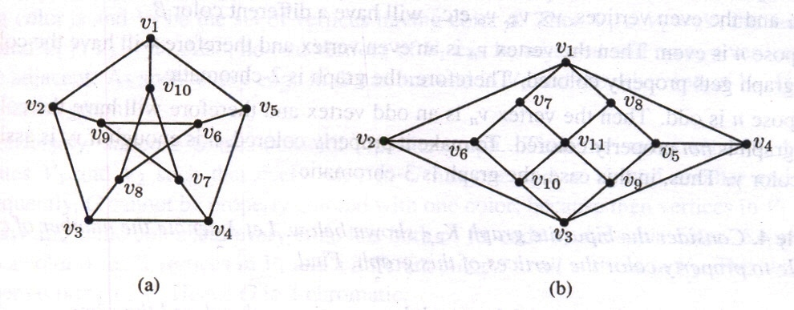 | L4 | CO6 | [8M]
 | OR
18 | Write algorithm for DFS and explain with example | L5 | CO6 | [8M]

-- 00 -- 00 –

